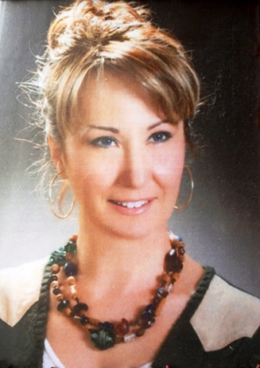

Prof.Dr.ÇİĞDEM ELMAS
Dr. Elmas graduated from The Middle East Technical University (METU), Ankara, Turkey with a Bachelor’s degree from Biology in 1992 by entering the honor list. She completed her master’s degree thesis about “fetal olfactroy mucosa” in 1999 and received a PhD in Histology and Embryology from University of Gazi, Ankara, Turkey in 2004 with her thesis which was investigating “the various CD molecules in thymus until puberty”. After her Research Assistant degree, a lecturer in 2004 and became an assistant professor in 2007. Awarding the title of Associate Professor on December 2008 and assigned to the staff of Professor on November 2014 in University of Gazi, Ankara, Turkey.
She has made some observations in “cell culture, regenerative and antiaging medicine” subjects in US in the State of Minnesota, St.Cloud State University and Mayo Clinic in Rochester. Dr. Elmas also represented her department in many international and intranational conferences successfully. She has numerous declaration of the international congress proceedings of the national.
Dr. Elmas has numerous researches on scanning and transmission electron microscopy and also has spesific studies on issues especially in dentistry, plastic reconstructive aesthetic surgery and tissue regeneration.
She has board of director and general secretary of Turkish Society of Histology and Embryology also Dr. Elmas has many of the congress organizing committee membership.
Dr. Elmas is the recipient of several awards with the researches about plastic reconstructive aesthetic surgery, pediatric gonadal functions and extremity surgery.
She has more than 60 publications in leading scientific journals and also writing and rendering several textbooks chapters about histology. Dr. Elmas has a mini-review about plastic reconstructive aesthetic surgery and also has seminar presentations about neuroplasticity.

